OUTPUT :
1) Create any database name
MariaDB [(none)]> CREATE DATABASE lab5_dbms;
Query OK, 1 row affected (0.002 sec)
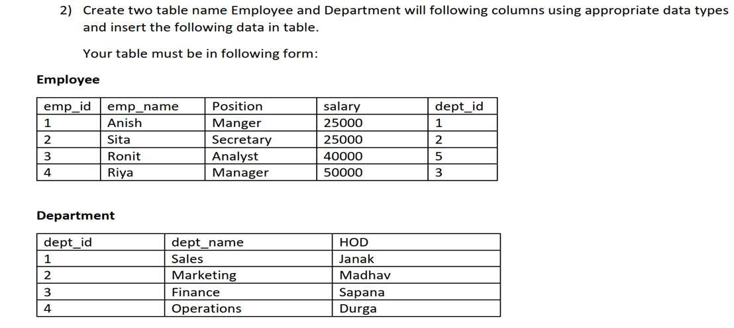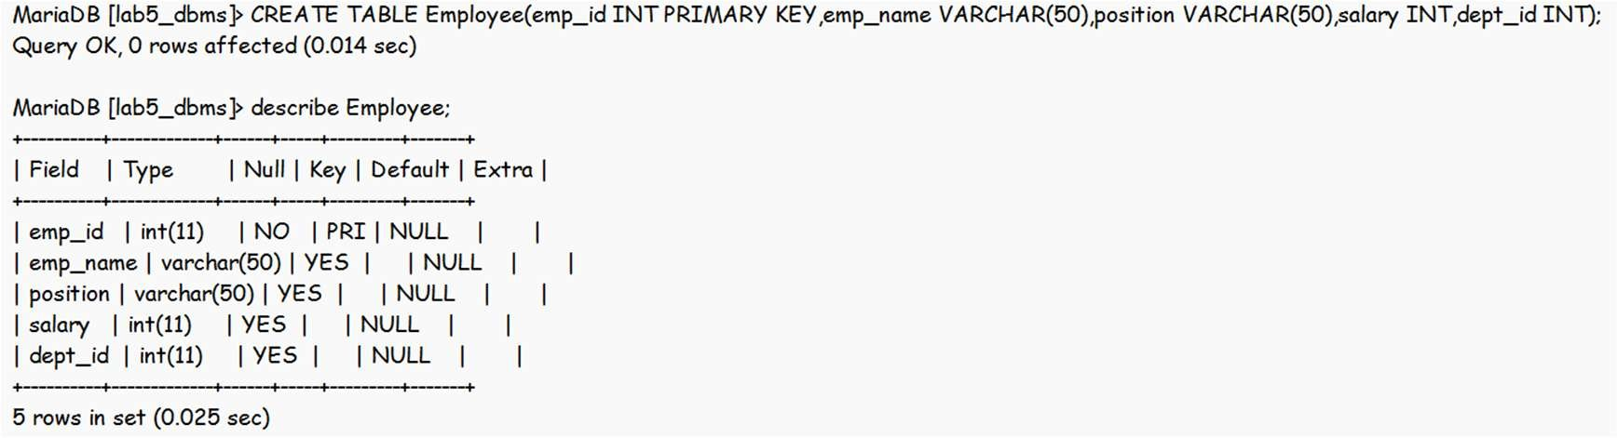

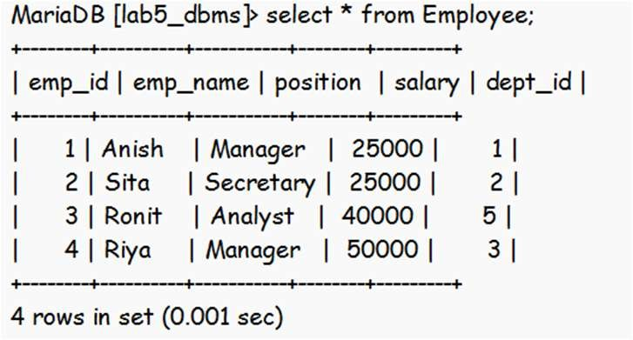

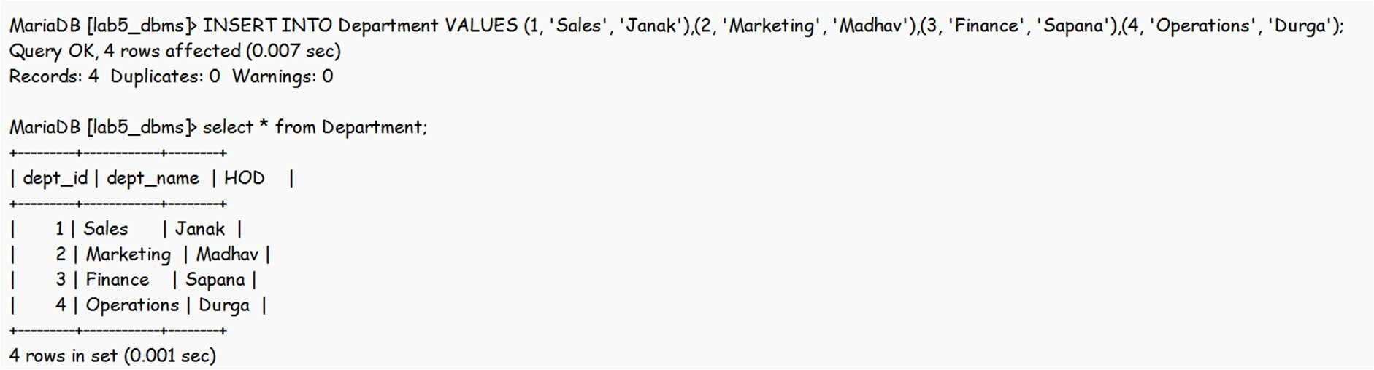

3) Now perform the following Join Operations
- Inner Join
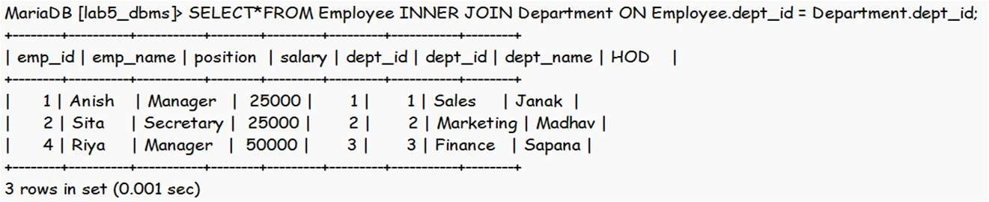
- Outer Join
- Left Outer Join
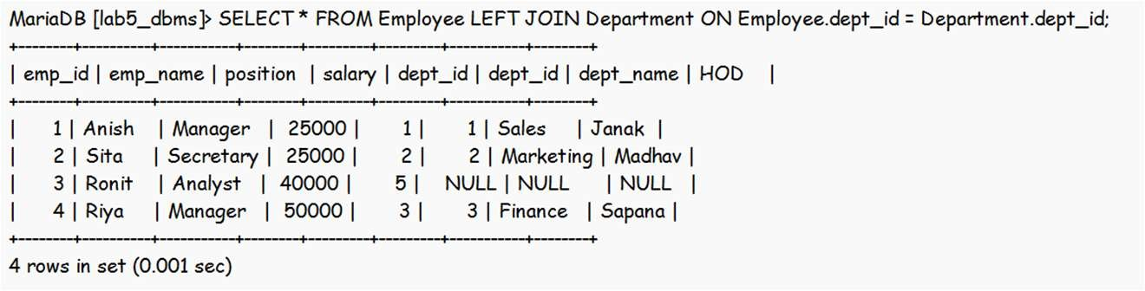
- Right Outer Join
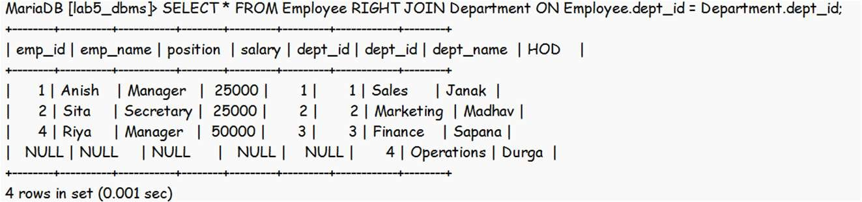
- Full Join
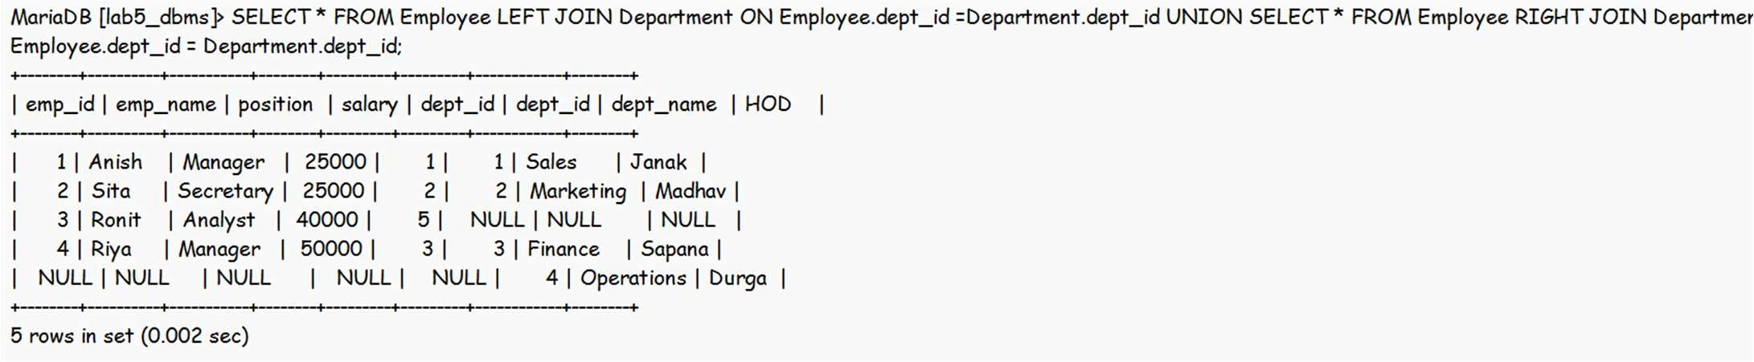
- Natural Join
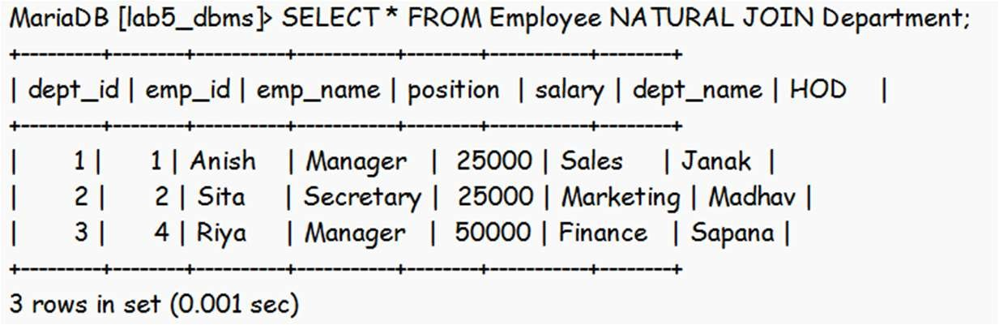

- Cross Join
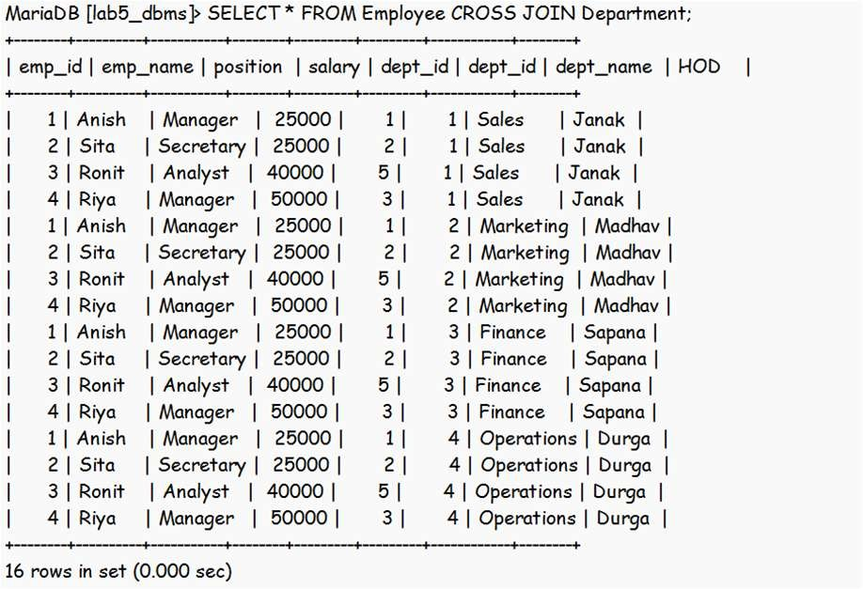
4) Write SQL queries to
- Find Employee names with their department
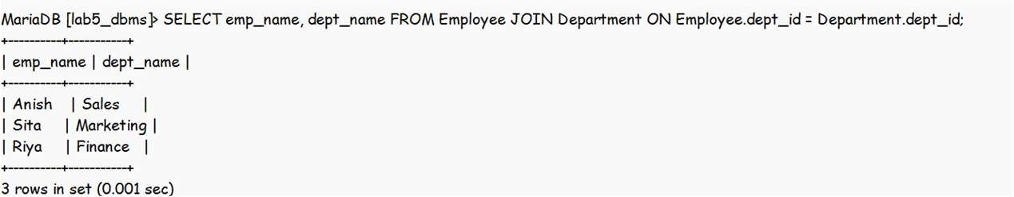
- Find emp_name,position,salary of employee who works in finance department
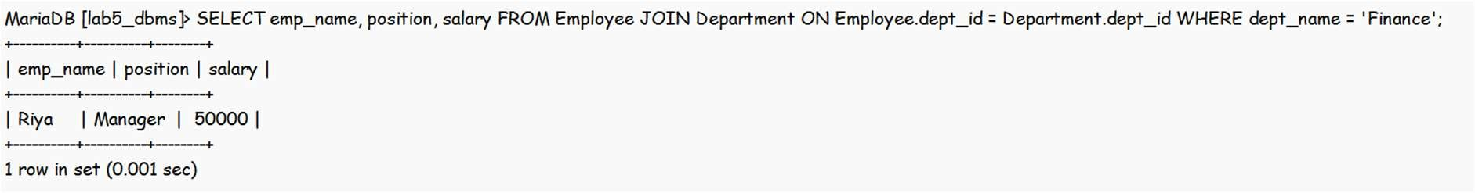
- Find emp_name of employee who works in sales department
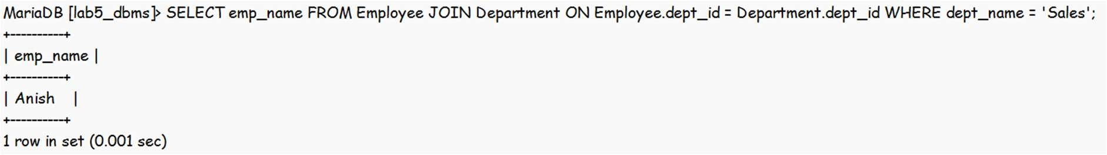
- Find the information of employee who works in marketing department
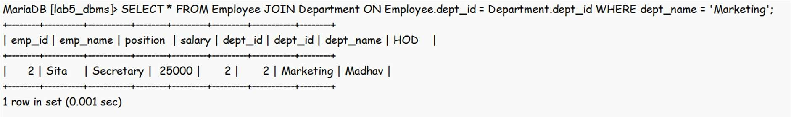
- Find the HOD of Riya
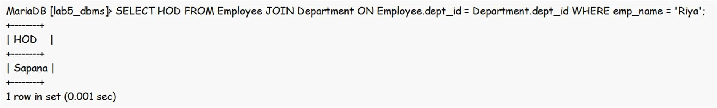

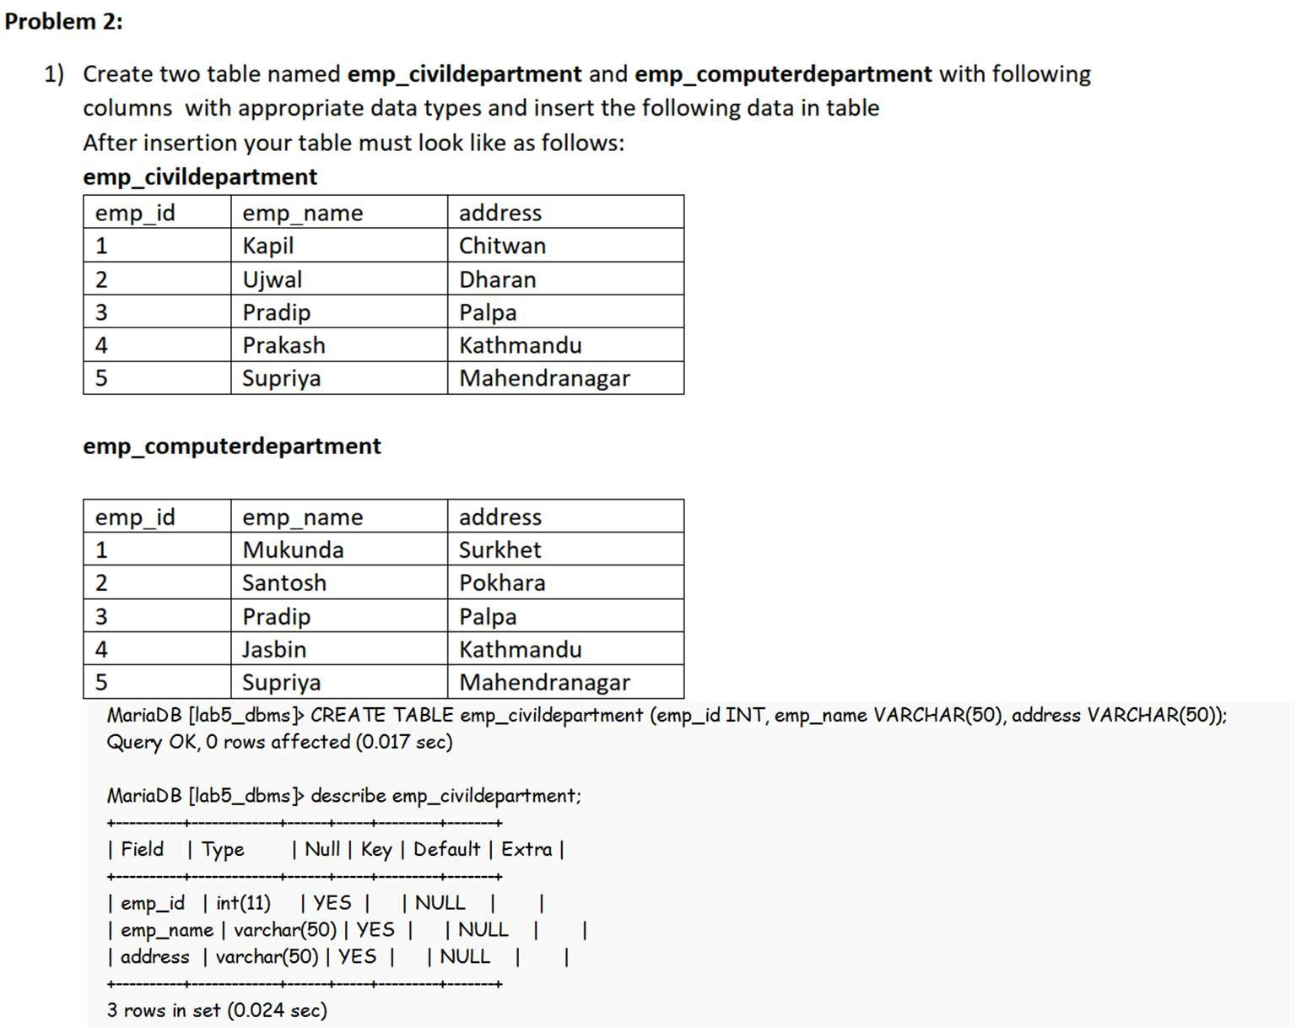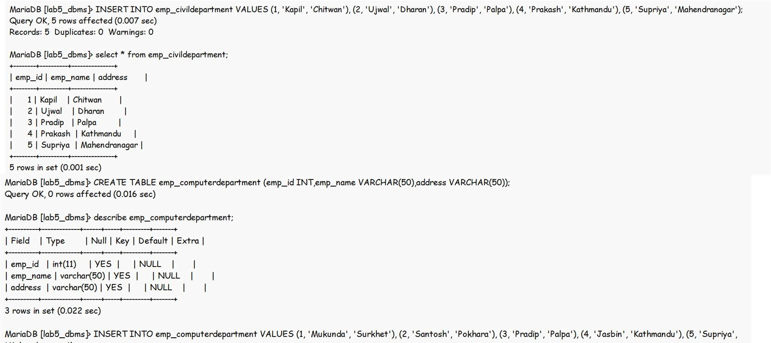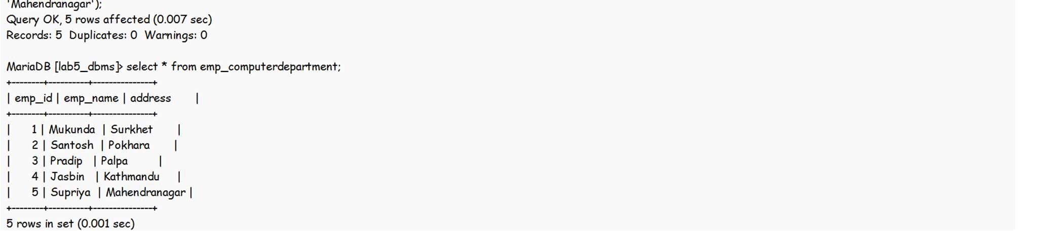

- perform the following set operations
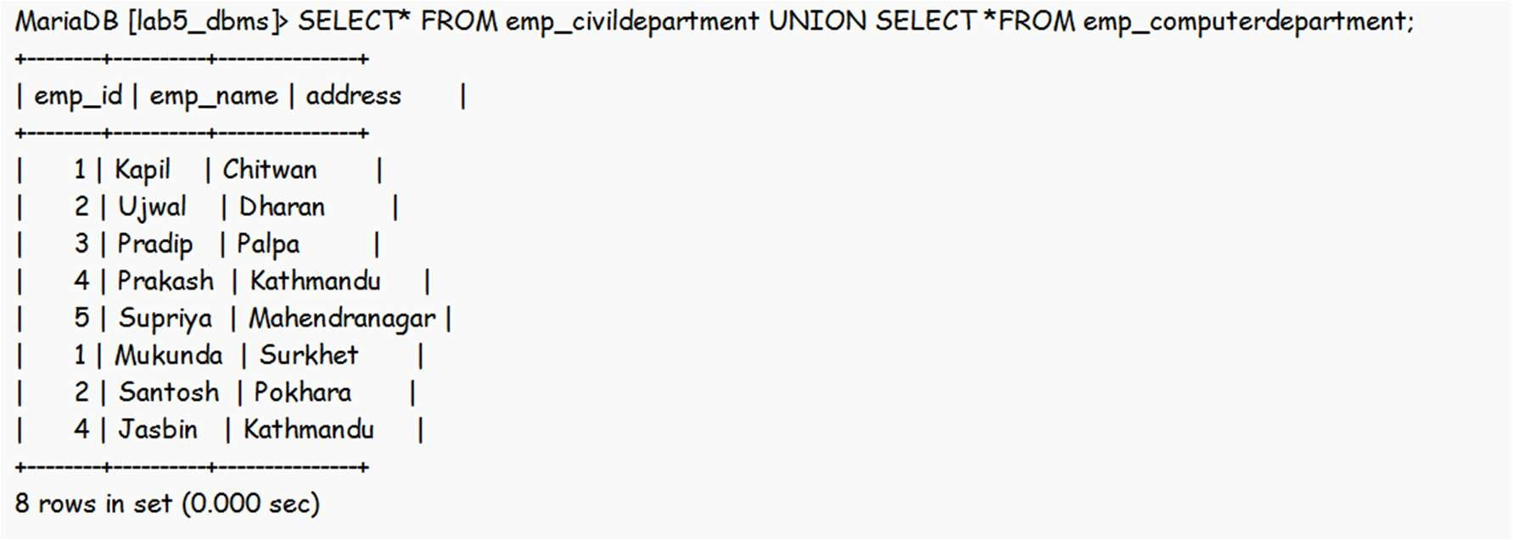
  - UNION

  - UNION ALL
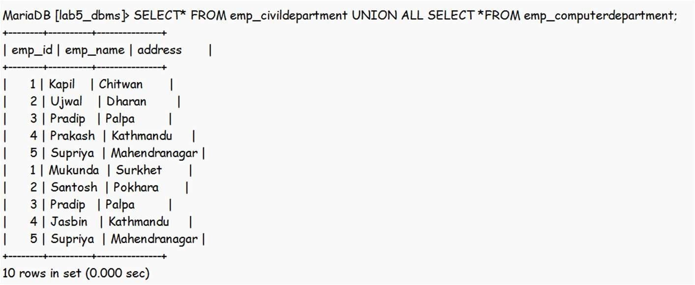
  - INTERSET
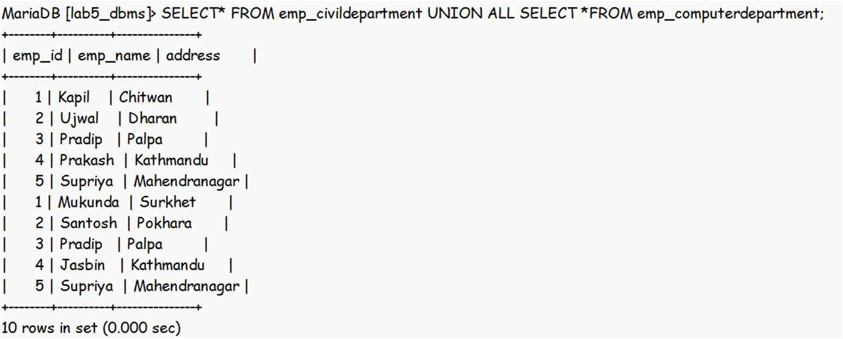
  - EXCEPT
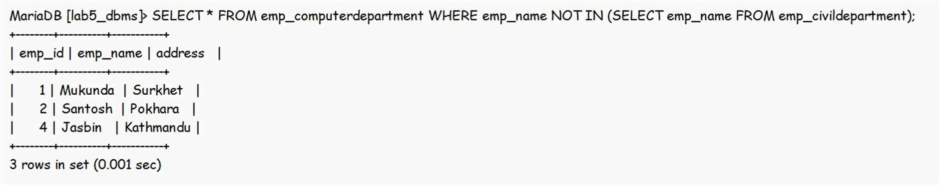
- Write SQL queries for the following:
- Find the name of employee who works either civil or computer department
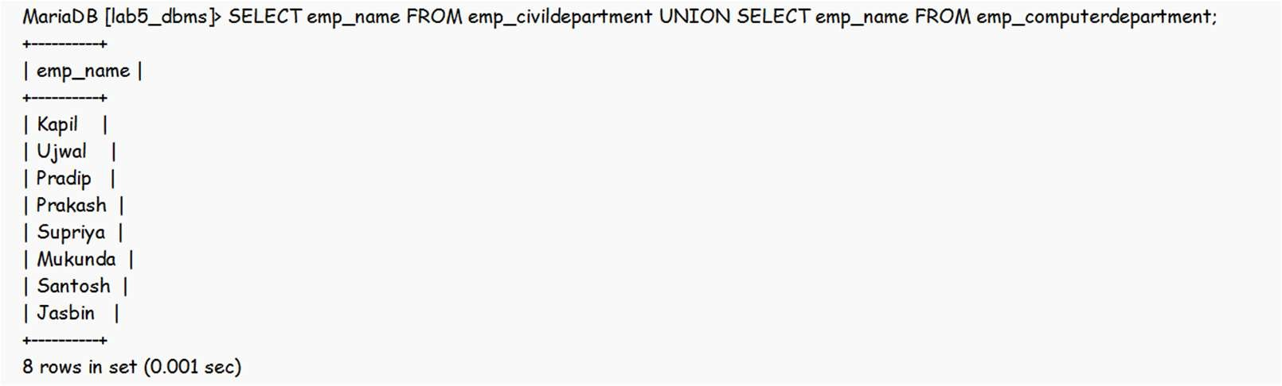
- Find the name of employee who works in both civil and computer department
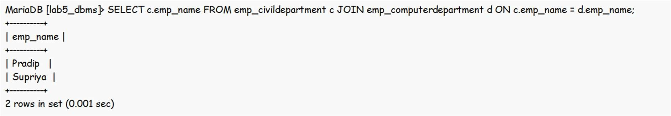

- Find the name of employee who works in computer department but not in civil department.
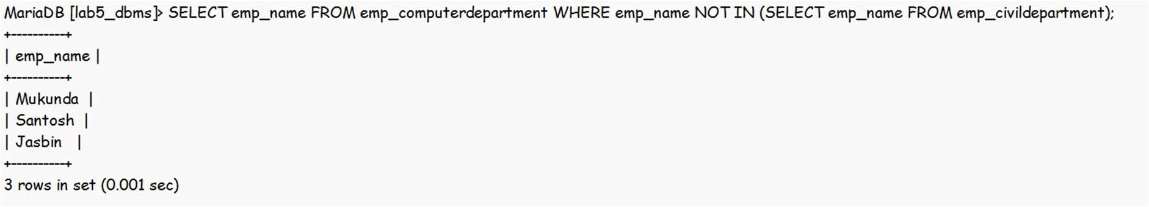
- Find the common address of where both computer and civil department employee lives in .
